PHASE 01 — API & Client-Server Fundamentals

Task 01 — Explore an API Using a Browser
Open the following API endpoint in your browser:
https://jsonplaceholder.typicode.com/posts/1

Perform
- Open the URL.
- Observe the response.
- Identify the returned JSON fields.
- Record the values of:
  - userId
  - id
  - title
  - Body

Then
Change the URL to:
https://jsonplaceholder.typicode.com/posts/2
and then:
https://jsonplaceholder.typicode.com/posts/3

Answer
The numbers 1, 2,3 etc refers to post Id, everytime we change this number we get data of that particular potss whose id is in the link we provided.

Evidence
☐ Screenshot of /posts/1
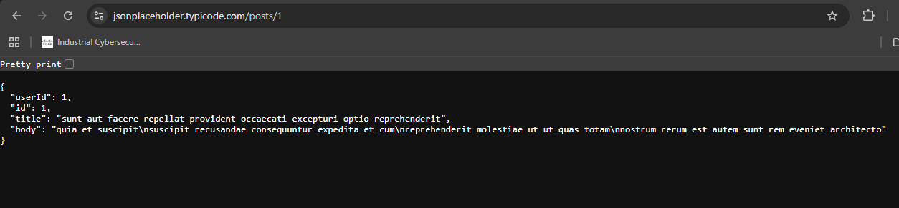
☐ Screenshot of /posts/2
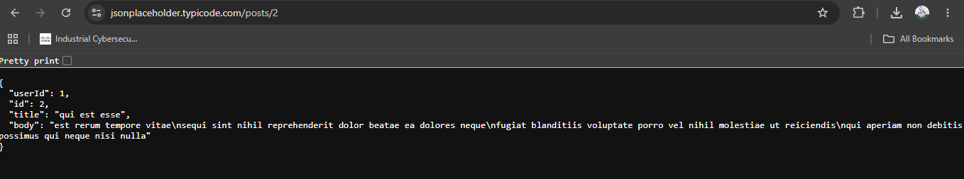
☐ Screenshot of /posts/3
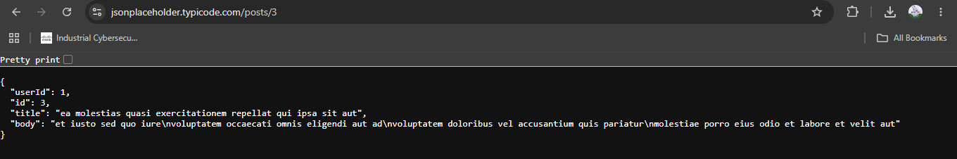
The activity directly follows the browser/API exercise in Phase 01.

Task 02 — Identify the Client, API and Server
Using the previous task, create a simple diagram showing:
Browser → API → Server → Response
Label each component.
Then write 3–5 sentences explaining what happens when the browser requests /posts/1.

Evidence
☐ Communication diagram
Browser (Chrome/PC/Device) -> API (URL) -> Server (System/device which is returning response) -> Response
☐ Written explanation
When browser request /posts/1, it goes the server mentioned in url and hit posts API with parameter 1 and then API returns data (in JSON format) of that particular post of a user whose id was sent and we get the response in browser.

Task 03 — Identify API Resources
Using JSONPlaceholder, investigate the following:
/posts
/posts/1
/posts/2
For each endpoint, identify:
Endpoint | Resource | Specific Resource?
/posts | Returns all posts | Collection of resources
/posts/1 | Returns post whose id is 1 | One specific resource with id 1
/posts/2 | Returns post whose id is 2 | One specific resource with id 2

PHASE 02 — HTTP Requests, Responses & REST

Task 04 — Analyze a URL
Analyze this URL:
https://api.example.com/students/101
Identify:
- Protocol
- Host
- Path
- Resource
- Resource identifier
Submit your answer in a table.
The URL structure and endpoint concepts are explicitly covered in Phase 02.
Answer:
Protocol | http
Host | api.example.com
Path | /students/101
Resource | Students
Resource Identifier | 101

Task 05 — Build a REST API Operation Table
Complete the following table.
Operation | HTTP Method | Endpoint
Retrieve all students | Get | /students
Create a student | Post | /students
Retrieve student 101 | Get | /students/101
Update student 101 | Put | /students/101
Delete student 101 | delete | /students/101
Then explain why different HTTP methods are used for different operations.
The expected method/resource relationship is based on GET, POST, PUT and DELETE in the provided material.
Answer:
Different HTTP methods are used for different purposes. We cannot update or delete data using the GET method because it is used only to retrieve data. The POST method is used to create new data, the PUT method is used to update existing data, and the DELETE method is used to remove data. Using different HTTP methods helps the API understand which operation the client wants to perform.

Task 06 — Test GET Requests
Using JSONPlaceholder:
- Send a GET request to /posts/1.
- Send a GET request to /posts/2.
- Send a GET request to /posts/3.
For each request record:
- Endpoint
- HTTP method
- Status code
- Response body

Evidence
☐ Three successful API requests
Endpoints:
https://jsonplaceholder.typicode.com/post/1 https://jsonplaceholder.typicode.com/post/2 https://jsonplaceholder.typicode.com/post/3
HTTP method: get
☐ Recorded status codes
Status Codes: 304
☐ Response data
Placed screenshots in phase 1, task 1

Task 07 — Test POST
Create a new post using a POST request.
Use a request body containing:
{
"title": "My API Lab",
"body": "Testing POST request",
"userId": 1
}
Record:
- HTTP method
- Endpoint
- Request body
- Response status code
- Response body
The task is based on the POST/create-resource example in Phase 02.
Answer:
HTTP methods | POST
Endpoint | https://jsonplaceholder.typicode.com/posts
Request body | {  "title": "My API Lab",  "body": "Testing POST request",  "userId": 1  }
Response status code | 201
Response body | {  "title": "My API Lab",  "body": "Testing POST request",  "userId": 1,  "id": 101  }

Task 08 — Test PUT
Update a resource using PUT.
Use:
PUT /posts/1
Create an updated JSON body.
Record:
- Request method
- Endpoint
- Request body
- Status code
- Response
The task is based on the PUT/update operation covered in Phase 02.
Answer:
Request method | PUT
Endpoint | https://jsonplaceholder.typicode.com/posts/1
Request body | {  "title": "Umaima Update",  "body": "Testing POST request",  "userId": 1  }
Status code | 200
Response | {  "title": "Umaima Update",  "body": "Testing POST request",  "userId": 1,  "id": 1  }

Task 09 — Test DELETE
Send:
DELETE /posts/1
Record:
- Request method
- Endpoint
- Status code
- Response
Explain what the DELETE operation is intended to accomplish.
Answer:
Request method | DELETE
Endpoint | https://jsonplaceholder.typicode.com/posts/1
Status code | 200
Response | {}

Task 10 — Investigate HTTP Status Codes
Perform requests that allow you to observe different HTTP status codes.
At minimum, investigate:
- 200
- 201
- 404
For each status code, record:
Status Code | Meaning | Your Test
200 | OK | Request complete (hitting https://jsonplaceholder.typicode.com/posts/1)
201 | Created | When new record is created (hitting https://jsonplaceholder.typicode.com/posts)
404 | Not Found | When API does not return any data (hitting https://jsonplaceholder.typicode.com/posts/101)
Then explain the difference between a successful request and a resource-not-found response.
The supplied material explicitly distinguishes 2xx success and 404 resource-not-found behavior.
Answer:
A successful request means the server has processed the request successfully. For example, status code 200 means the requested data was retrieved successfully, while 201 means a resource was created successfully. A 404 Not Found response means the requested resource does not exist on the server. Therefore, 200 and 201 indicate success, while 404 indicates that the requested resource could not be found.

PHASE 03 — JSON & Python API Integration

Task 11 — Create a JSON Student Record
Create the following JSON object:
{
"name": "Ali",
"marks": 85,
"program": "BSCS"
}
Then create the equivalent Python dictionary.

Perform
- Store the data in a Python dictionary.
- Print the student's name.
- Print the student's marks.
- Print the student's program.
JSON objects and their conceptual mapping to Python dictionaries are covered in Phase 03.
Answer:
Inside Phase3_task11.py file in repo

Task 12 — Work With a JSON Array
Create a JSON array containing at least three students.
Example structure:
[
{
"id": 1,
"name": "Ali"
},
{
"id": 2,
"name": "Sara"
}
]

Perform
Write Python code that:
- Stores the records in a list.
- Loops through all students.
- Prints each student's ID.
- Prints each student's name.
The supplied Phase 03 material specifically introduces JSON arrays as lists of dictionaries.
Answer:
Inside Phase3_task12.py file in repo

Task 13 — Create Your First Python API Client
Create a Python program that accesses:
https://jsonplaceholder.typicode.com/posts/1
Your program must:
- Send a GET request.
- Receive the response.
- Check the status code.
- Read the JSON response.
- Print the post ID.
- Print the post title.
- Print the post body.

Expected Output
Your terminal should display information similar to:
Status: 200
Post ID: 1
Title: ...
Body: ...

Evidence
☐ Python source code
☐ Terminal output
Answer:
Inside Phase3_task13.py file in repo
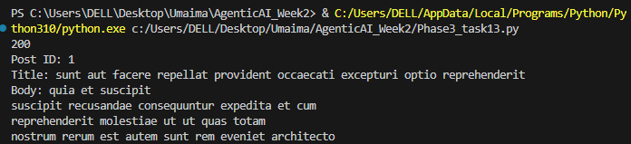

Task 14 — Retrieve Multiple API Records
Modify your Python program to retrieve:
/posts/1
/posts/2
/posts/3
Print:
Post 1: ...
Post 2: ...
Post 3: ...
Do not duplicate the complete program three times. Use appropriate Python logic.
Answer:
Inside Phase3_task13.py file in repo
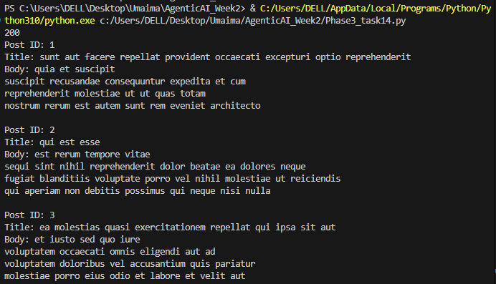

Task 15 — Retrieve and Process a Collection
Request:
https://jsonplaceholder.typicode.com/posts
Your program must:
- Retrieve the API response.
- Convert/process the JSON data.
- Determine the number of returned posts.
- Print the first five post titles.

Evidence
☐ Source code
☐ Terminal output
Answer:
Inside Phase3_task15.py file in repo
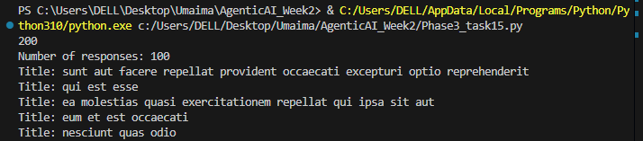

PHASE 04 — Authentication, API Keys & Secure Configuration

Task 16 — Public vs Protected API
Create a short comparison between a public API and a protected API.
Your comparison must include:
- Whether credentials are required
- Why authentication is used
- Example authentication mechanism
- What happens when credentials are invalid
The supplied material introduces public/protected APIs and API-key/token patterns.
Answer:
- A public API allows people or applications to access its available data without necessarily proving their identity.
- For example, an API might provide public weather information.
- A protected API requires valid credentials, such as an API key or access token, before allowing access to protected data or operations.
- For example, a banking API protects a customer's account information.
- Authentication helps the API verify who is making the request. It helps protect private data and prevent unauthorized access.
- If credentials are invalid, the API usually rejects the request, often returning 401 Unauthorized or 403 Forbidden.

Task 17 — Implement an Authorization Header
Create a Python request using an Authorization header following the pattern:
Authorization: Bearer TOKEN
Do not use a real credential in your submitted code.
Demonstrate that your program can construct the request headers correctly.

Evidence
☐ Python code
☐ Printed/sanitized request configuration
Answer:
Inside Phase3_task17.py file in repo

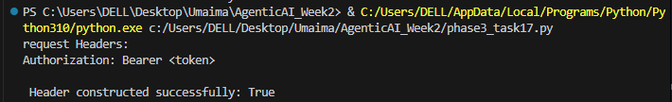

Task 18 — Move Credentials to .env
Create a .env file:
API_KEY=your_key_here
Then modify your Python program to obtain the value through an environment variable.
The source material specifically demonstrates .env and os.getenv() as the safer alternative to hardcoding credentials.

Requirements
☐ Create .env
☐ Store the API key in .env
☐ Load it using Python
☐ Do not write the key directly in the Python source
☐ Add .env to .gitignore
☐ Verify that the credential is excluded from version control

Important
Never submit your real API key to the instructor or Git repository.
Answer:
.env , . gitignore added
Edited files phase3_task13.py phase3_task14.py phase3_task15.py and used api key from .env

PHASE 05 — Errors, Timeouts & Rate Limits

Task 19 — Handle a 404 Error
Modify your Python API client so that it requests a resource that does not exist.
For example, request an invalid resource identifier.
Your program must:
- Send the request.
- Detect the 404.
- Print an appropriate error message.
- Continue/terminate gracefully without an unhandled exception.
The supplied material emphasizes that receiving an HTTP response does not mean the requested operation succeeded.

Expected behavior
Request failed.
Status Code: 404
Resource not found.

Task 20 — Handle Multiple HTTP Errors
Extend your program to distinguish between at least:
- Successful response
- 400
- 401
- 404
- 429
- 500
Create appropriate messages for each case.
Use the status-code categories provided in the lecture material rather than treating every failure identically.
Answer:
Inside Phase3_task20.py file in repo

Task 21 — Add Request Timeout
Modify your API request so that it includes a timeout.
For example:
requests.get(
url,
timeout=10
)
Then:
- Explain why the timeout is necessary.
- Add timeout handling.
- Prevent the program from remaining indefinitely waiting for a response.
The Phase 05 material explicitly introduces the timeout parameter and its purpose.
Answers:
- Imagine you send a request to an API, but the server is slow or stops responding. Without a timeout, your program might keep waiting for a long time. A timeout sets a maximum time the program will wait for the request.
For example, timeout=10 means the request will time out if the connection or response takes too long, based on the timeout rules of the requests library.
- Inside phase3_task21 in repo
- timeout=10: Sets the timeout for the request. try: Runs the request and processes the response. except requests.exceptions.Timeout: Handles the case where the request times out and prints a suitable message. except requests.exceptions.RequestException: Handles other request-related errors, such as connection problems.

Task 22 — Handle Network/API Failure
Modify your program so that it can gracefully handle a request failure.
Your program should distinguish between:
Successful request
API error
Timeout
Network/request failure
The supplied material identifies invalid requests, unauthorized requests, missing resources, rate limits, server failures, network failures and timeouts as possible API failures.
Answer:
Inside phase3_task21 in repo

Task 23 — Investigate Rate Limiting
Research the concept of API rate limiting using the explanation provided in the lecture.
Answer:
- What is a rate limit?
- Why do APIs impose rate limits?
- What does HTTP 429 mean?
- Why can an automated program generate too many requests?
- Why is this especially important for agentic systems?
The supplied material explicitly connects repeated automated requests and rate limits with agentic systems.
Answers:
- A rate limit is a limit on how many requests we can send to an API within a certain time.
- To prevent overloading the server and to make sure everyone gets a fair chance to use the API.
- It means Too Many Requests. We have sent more requests than the API allows.
- Because it can send requests repeatedly and very quickly without a person controlling each request.
- Agentic systems can perform tasks and make repeated API calls automatically. Without proper limits, they may send too many requests and overload the API or reach its usage limit.

PHASE 06 — From API Integration to Agent Tools
The supplied Phase 06 material only establishes the transition from API integration to agent tools. Therefore, these tasks should be treated as a practical transition exercise rather than as material directly specified in the slides.

Task 24 — Define an API Tool
Select one API operation you implemented in the previous phases.
Create a tool specification containing:
Tool Name: Get post
Description: Hit API and get a post
HTTP Method: GET
Endpoint: https://jsonplaceholder.typicode.com/posts/1
Required Inputs: 1
Optional Inputs: json contains id, title, body, userId
Expected Output: json contains id, title, body, userId
Possible Errors: 400, 401 404, 429,500
Authentication Required: No

Task 25 — Design an Agent Tool Interface
Convert your selected API operation into an agent-oriented tool definition.
For example:
Tool: get_post
Purpose:
Retrieve a post using its ID.
Input:
post_id
Output:
id
title
body
userId
Possible Errors:
404
429
500
Timeout
Do not build an AI agent yet. The objective is to understand how an API operation can be represented as a tool.

FINAL INTEGRATION PROJECT

Task 26 — Build a Complete API Client
Create a small Python application that demonstrates everything learned in Phases 01–05.
Your application must:

API Communication
☐ Connect to an API.
☐ Use an appropriate HTTP method.
☐ Use a valid endpoint.
☐ Send the request.

JSON Processing
☐ Receive JSON.
☐ Parse/process the JSON.
☐ Extract selected fields.
☐ Display useful information.

Authentication
☐ Demonstrate authentication if the selected API requires it.
☐ Do not hardcode credentials.
☐ Use environment variables for credentials.

Error Handling
☐ Check HTTP status codes.
☐ Handle 404.
☐ Handle authentication failure where applicable.
☐ Handle request/network failure.
☐ Handle timeout.
☐ Consider rate limiting.

Documentation
☐ Document the API endpoint.
☐ Document the HTTP method.
☐ Document required parameters.
☐ Document request body, if applicable.
☐ Document response structure.
☐ Document possible errors.
☐ Explain how the API operation could later become an agent tool.

FINAL DELIVERABLE
Submit a folder containing:
API-Lab/
│
├── phase01/
│
├── phase02/
│
├── phase03/
│ └── api_client.py
│
├── phase04/
│ ├── api_client.py
│ ├── .env.example
│ └── .gitignore
│
├── phase05/
│ └── api_client.py
│
├── phase06/
│ └── tool_specification.md
│
├── final_project/
│ ├── src/
│ ├── README.md
│ └── requirements.txt
│
└── evidence/
├── task01.png
├── task06.png
├── task07.png
├── task13.png
├── task18.png
├── task19.png
└── ...

